Nama : Adridinan Najmi Faza
NIM : H1D025059
Shift Awal/Akhir : B/H

- Berdasarkan tabel yang telah dibuat pada praktikum sebelumnya untuk skema orderentry tampilkan data data berikut ini :

- Tampilkan data customer secara terurut dari a sampai z
MariaDB [orderentry]> select * from customers order by cust_name asc;
+---------+----------------+------------------+-----------+------------+----------+--------------+--------------+---------------------+
| cust_id | cust_name | cust_adress | cust_city | cust_state | cust_zip | cust_country | cust_contact | cust_email |
+---------+----------------+------------------+-----------+------------+----------+--------------+--------------+---------------------+
| 10005 | e fudd | 4545 53rd street | chicago | IL | 54545 | USA | E Fuad | NULL |
| 10002 | Mouse House | 333 fromage lane | columbus | OH | 43333 | USA | jerry mouse | NULL |
| 10003 | wascals | 1 sunny place | muncie | in | 42222 | USA | jim jones | rabith@wascally.com |
| 10004 | yosemite place | 829 riverside | phoenix | AZ | 88888 | USA | Y Sam | sam@yosesite.com |
+---------+----------------+------------------+-----------+------------+----------+--------------+--------------+---------------------+
4 rows in set (0.000 sec)
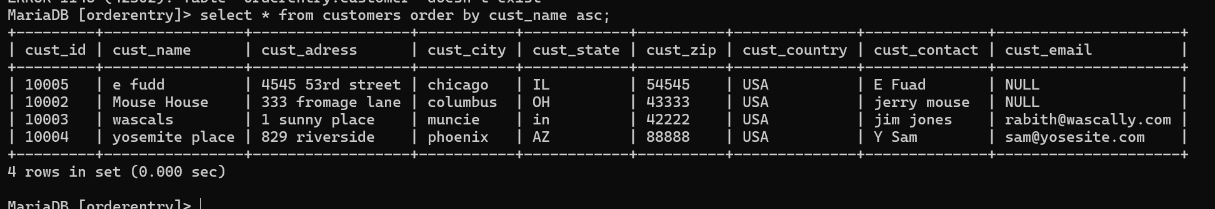

- Tampilkan data vendor dan total vendors serta urutkan dari z ke a
MariaDB [orderentry]> select * from vendors order by vend_name desc;
+---------+----------------+-----------------+-------------+------------+----------+--------------+
| vend_id | vend_name | vend_adress | vend_city | vend_state | vend_zip | vend_country |
+---------+----------------+-----------------+-------------+------------+----------+--------------+
| 1002 | LT Supplies | 500 Park Street | Anytown | OH | 44333 | USA |
| 1006 | Jouets Et Ours | 1 Rue Amusement | Paris | NULL | 45678 | France |
| 1005 | Jet Set | 42 Galaxy Road | London | NULL | N16 6PS | England |
| 1004 | Furball Inc. | 111 Main Street | New York | NY | 11115 | USA |
| 1001 | Anvils R Us | 123 Main Street | Southfield | MI | 48075 | USA |
| 1003 | ACME | 555 High Street | Los Angeles | CA | 90046 | USA |
+---------+----------------+-----------------+-------------+------------+----------+--------------+
6 rows in set (0.000 sec) 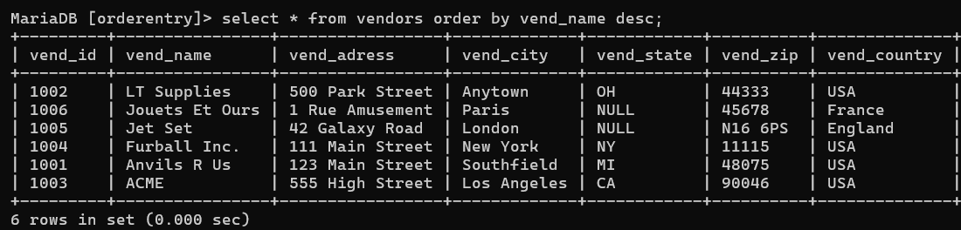

total vendors :
MariaDB [orderentry]> select count(vend_id) As Total from vendors;
+-------+
| Total |
+-------+
| 6 |
+-------+
1 row in set (0.001 sec)
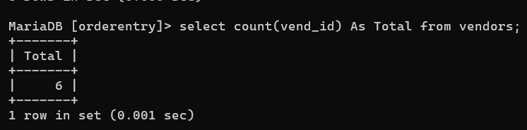
- Tampilkan data detail penjualan dari order item berdasarkan dari jumlah penjualan terbanyak
MariaDB [orderentry]> select * from orderitems order by quantitiy desc;
+-----------+------------+-----------+-----------+
| order_num | order_item | prod_item | quantitiy |
+-----------+------------+-----------+-----------+
| 20008 | 1 | 0 | 100 |
| 20009 | 1 | 0 | 50 |
| 20005 | 1 | 0 | 10 |
| 20005 | 3 | 0 | 5 |
| 20005 | 2 | 0 | 3 |
| 20006 | 1 | 0 | 1 |
| 20007 | 1 | 0 | 1 |
| 20009 | 2 | 0 | 1 |
| 20009 | 3 | 0 | 1 |
| 20009 | 4 | 0 | 1 |
| 20009 | 5 | 0 | 1 |
+-----------+------------+-----------+-----------+
11 rows in set (0.000 sec)
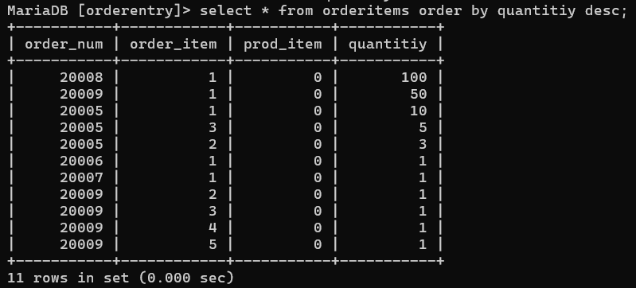

- Carilah banyaknya, total, rata-rata, jumlah minimal, jumlah maksimal dari quantity penjualan. Data berasal dari tabel orderitems
MariaDB [orderentry]> select count(quantitiy) as Banyaknya,sum(quantitiy) as Total, avg(quantitiy) as rata_rata, min(quantitiy) as jum_minimal, max(quantitiy) as jum_maximal from orderitems;
+-----------+-------+-----------+-------------+-------------+
| Banyaknya | Total | rata_rata | jum_minimal | jum_maximal |
+-----------+-------+-----------+-------------+-------------+
| 11 | 174 | 15.8182 | 1 | 100 |
+-----------+-------+-----------+-------------+-------------+
1 row in set (0.000 sec)

MariaDB [orderentry]>
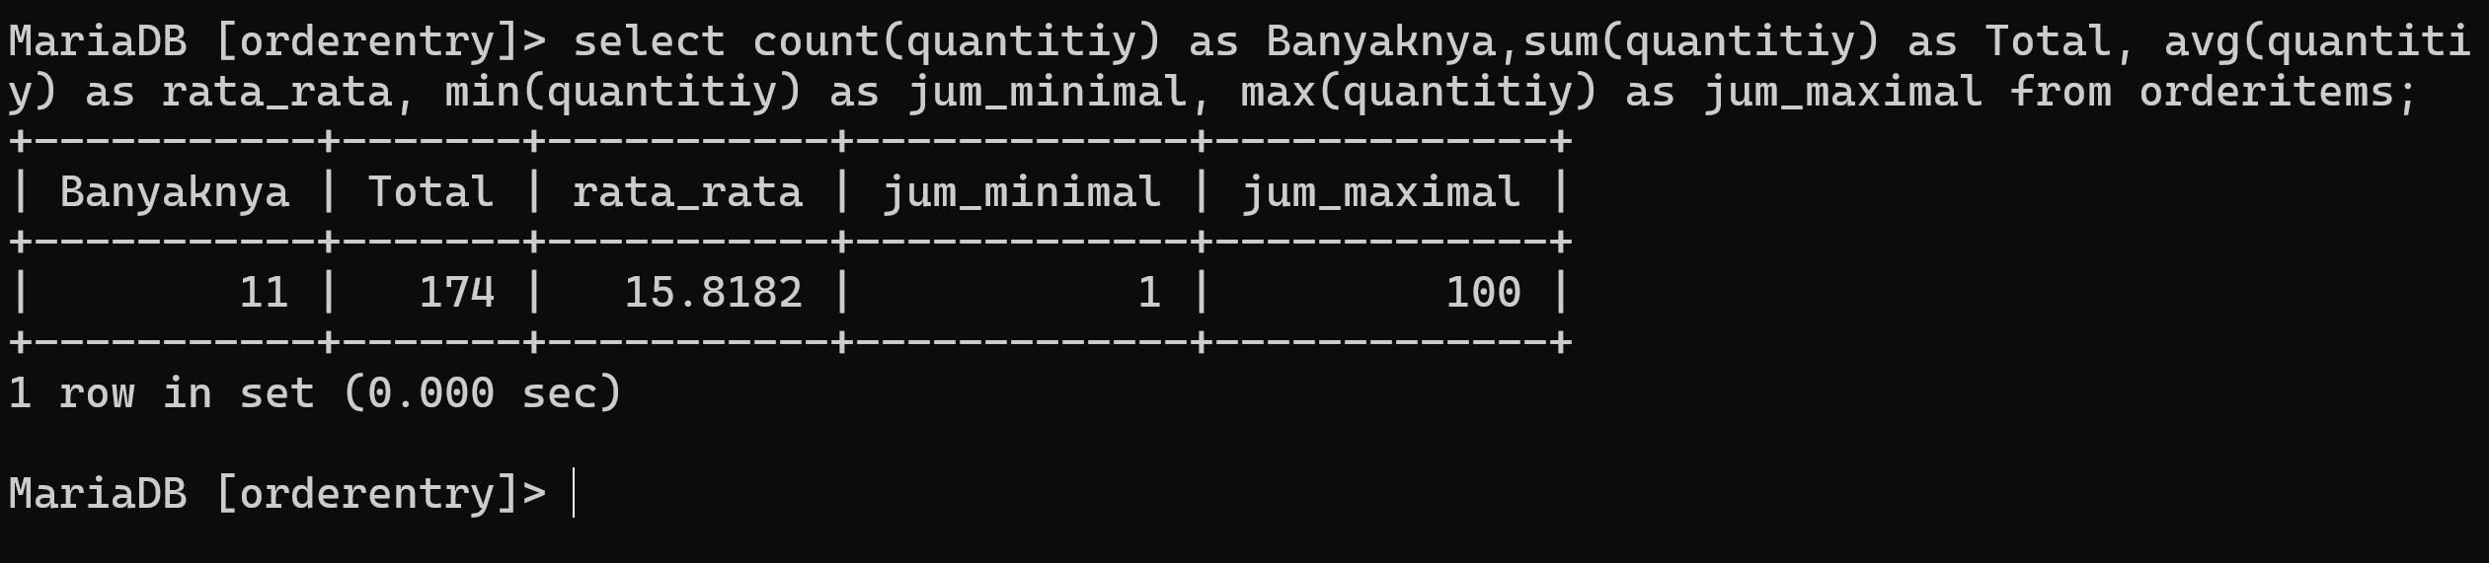

- Tampilkan nomer order yang memiliki total quantity antara 5-10
MariaDB [orderentry]> select order_num from orderitems where quantitiy between '5' and '10';
+-----------+
| order_num |
+-----------+
| 20005 |
| 20005 |
+-----------+
2 rows in set (0.004 sec)
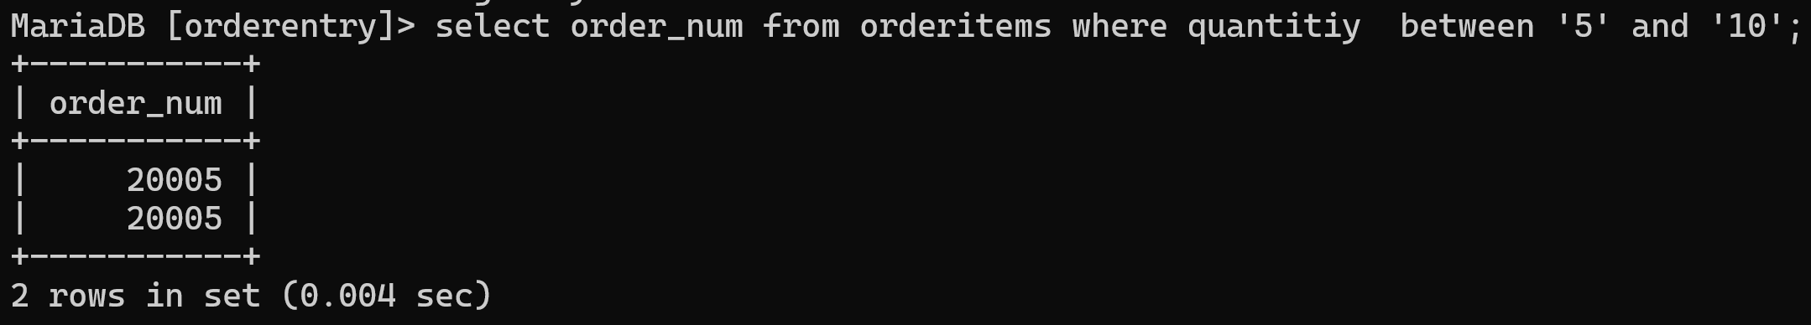

- Tampilkan data vendor id yang berasal dari "USA"
MariaDB [orderentry]> select vend_id from vendors where vend_country in ('USA');
+---------+
| vend_id |
+---------+
| 1001 |
| 1002 |
| 1003 |
| 1004 |
+---------+
4 rows in set (0.005 sec)
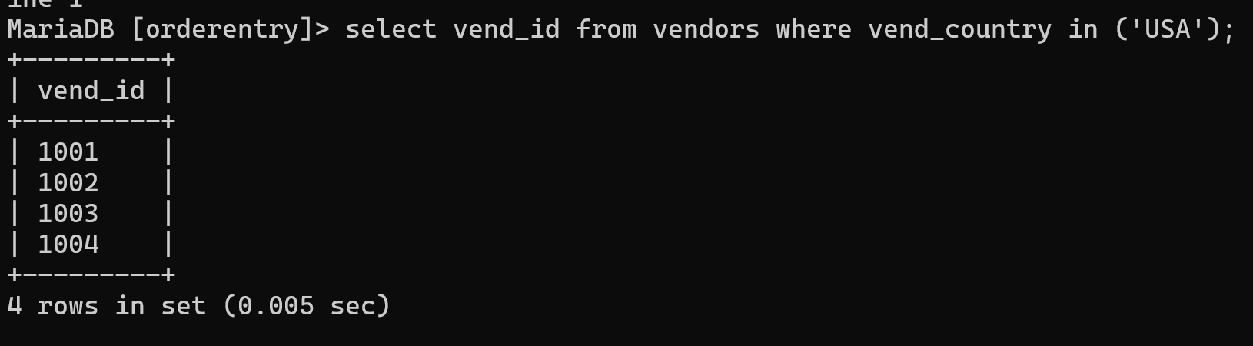

- Tampilkan Nama Produk dan Nama Vendor yang mengandung huruf P
Nama Produk :

MariaDB [orderentry]> select prod_name from products where prod_name like '%p%';
+--------------+
| prod_name |
+--------------+
| JetPack 1000 |
| JetPack 2000 |
+--------------+
2 rows in set (0.000 sec)
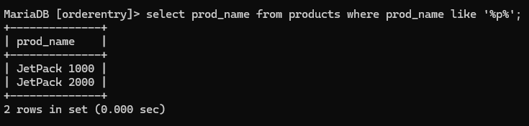

Nama Vendor :

MariaDB [orderentry]> select vend_name from vendors where vend_name like '%p%';
+-------------+
| vend_name |
+-------------+
| LT Supplies |
+-------------+
1 row in set (0.000 sec)
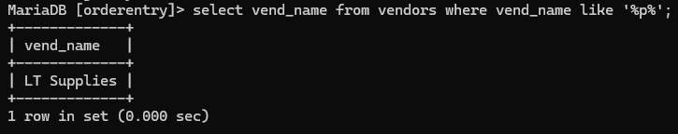

- Tampilkan data prod_name sebagai nama produk dan harganya.
MariaDB [orderentry]> select prod_name as 'nama produk', prod_price as 'harga' from products;
+----------------+-------+
| nama produk | harga |
+----------------+-------+
| 0.5 ton anvil | 5 |
| 1 ton anvil | 10 |
| 2 ton anvil | 20 |
| Detonator | 13 |
| Bird seed | 10 |
| Carrots | 3 |
| Fuses | 3 |
| JetPack 1000 | 35 |
| JetPack 2000 | 55 |
| Oil can | 9 |
| Safe | 50 |
| Sling | 4 |
| TNT (1 stick) | 3 |
| TNT (5 sticks) | 10 |
+----------------+-------+
14 rows in set (0.000 sec)
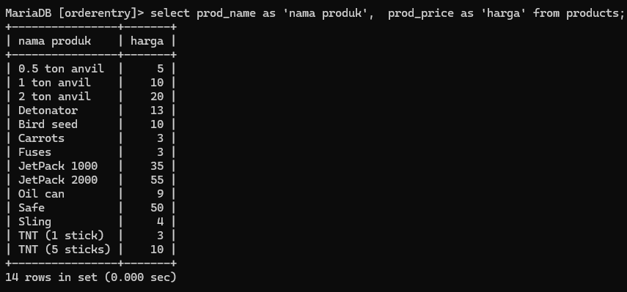

- Operasikan perintah SQL untuk menampilkan :

  - Tanggal praktikum
MariaDB [orderentry]> select current_date as 'Tanggal Praktikum';
+-------------------+
| Tanggal Praktikum |
+-------------------+
| 2025-10-24 |
+-------------------+
1 row in set (0.000 sec)
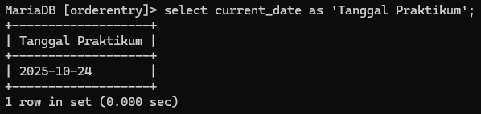

  - Jam sekarang
MariaDB [orderentry]> select current_time as jam_sekarang;
+--------------+
| jam_sekarang |
+--------------+
| 12:52:52 |
+--------------+
1 row in set (0.000 sec)
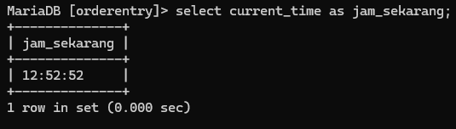
  - Jam sekarang - jam awal masuk praktikum
MariaDB [orderentry]> select current_time as 'jam sekarang', time '09:00:00' as 'Jam Awal Masuk Praktikum';
+--------------+--------------------------+
| jam sekarang | Jam Awal Masuk Praktikum |
+--------------+--------------------------+
| 13:01:09 | 09:00:00 |
+--------------+--------------------------+
1 row in set (0.001 sec)

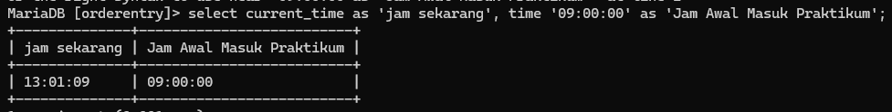
  - Tahun Sekarang - Tahun Lahir anda
MariaDB [orderentry]> select year(current_date) as 'Tahun Sekarang', 2006 as 'Tahun Lahir Saya';
+----------------+------------------+
| Tahun Sekarang | Tahun Lahir Saya |
+----------------+------------------+
| 2025 | 2006 |
+----------------+------------------+
1 row in set (0.000 sec)
